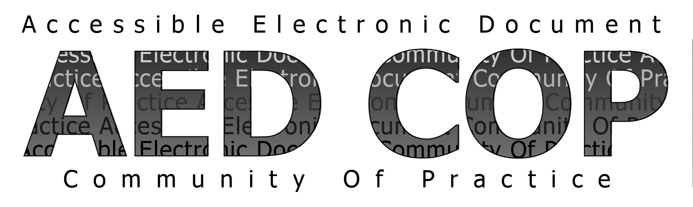

Basic Authoring and Testing Checklist - MS WORD 2010
January 2015 Version 1.0

Document
1 Did you save as a Word Document (.docx) with a descriptive filename? | Yes | No
The file type is Word 2010 document (.docx).
The filename identifies the document or its purpose.

Headings
2 Did you use styles to creat headings? | Yes | No | NA
All headings appear in the Navigation Pane.
The navigation pane matches the visual outline of the document.

Lists
3 Did you use built-in features to create lists? | Yes | No | NA
When lists are selected, built-in list features are highlighted on the Ribbon.

Columns
4 Did you use built-in columns to organize content? | Yes | No | NA
For text in columns, Columns is listed under Section in the Reveal Formating Pane.

Layout Tables
5 Did you use built-in features to organize content in layout tables? | Yes | No | NA
The tab order of layout tables matches the visual layout.
Text Wrapping is set to “None” in Table Properties.

Language
6 Did you identify distinct languages? | Yes | No | NA
When text is in a different language, the correct language is identified.

Links
7 Did you create unambiguous names for links? | Yes | No | NA
The destination, function or purpose is described in the link name or in surrounding text.
Links are uniquely identified.

Headers, Footers, and Watermarks
8 Did you duplicate vital information in headers, footers, and watermarks? | Yes | No | NA
Vital information in headers, footers, and watermarks is duplicated at or near the start of the related information.

Data Tables
9 Did you use built-in features to create data tables? | Yes | No | NA
When data tables are selected, the Table Tools Tab appears (and the Picture Tools Tab does not).
The table is simple; there are no merged or split cells.
There is only one row of headers.
The first row is set to “Repeat as Header Row.”
Text Wrapping is set to “None” in Table Properties.

Images and Other Objects
10 Did you create accessible images and other objects? | Yes | No | NA
There is descriptive text in the Alt-Text, Caption, surrounding text or appendix.
The descriptive text on images of text matches verbatim.
“Double-quote, space, double-quote” has been entered for decorative objects.
There are no meaningful images reported under “Object not In Line” in the Accessibility Checker.

Text Boxes
11 Did you create accessible text boxes? | Yes | No | NA
There are no Text Boxes under “Object not In Line” in the Accessibility Checker.

Color and Sensory Characteristics
12 Did you use color (and other sensory characteristics) plus text to convey meaning? | Yes | No | NA
The meaning of color or other sensory characteristics is duplicated in text.

Color Contrast
13 Did you create the required color contrast? | Yes | No | NA
Text and Large Text (including images of text, excluding logos) pass with the Color Contrast Analyzer.

Audio, Video, and Multimedia
14 Did you create accessible embeded files? | Yes | No | NA
Audio-only content has an accurate and complete transcript.
Video-only content has an accurate and complete description.
Multimedia has accurate and complete synchronized captions.
Multimedia has accurate and complete synchronized audio descriptions.

Forms
15 Did you avoid forms? | Yes | No
Fillable form fields are excluded from the document.

Flashing Objects
16 Did you exclude flashing objects? | Yes | No
Flashing objects are excluded from the document.

Alternative Accessible Version
17 Did you provide an alternative accessible version? | Yes | No | NA
An alternate version is provided and the information is equivalent and up to date with the primary document.

